Accurate diagnostic of electron beam characteristics

U. Reisgen, S. Olschok, J. de Vries, A. Backhaus, S. Ufer, RWTH Aachen University - Welding and Joining Institute
S. Tiedke, T. Schmitz-Kempen, B. Reichenberg, E. Drichel, aixACCT GmbH

Diabeam II - potential for online quality control in electron beam welding

Introduction

The electron beam is a tool which is capable to provide welds wich meet highest standards of quality and reproducibility.
In every modern production chain where special attention is set on consistent quality of production, the metrological supervision of the production tools is part of the standard.
Currently, several hundred machines for electron beam welding are applied in Europe, especially in the fields of research and development, aircraft and aerospace industry and also for special applications in the field of automotive. Particularly the joining tasks in the aircraft and aerospace industry require a beam tool which meets the highest demands made to the reproducibility during serial production. Especially there, a correctly-aligned and optimally stigmatized beam is necessary to achieve a consistent manufacturing standard. In order to meet this requirement, extensive measuring and test welds are carried out every time after the beam generator has been manipulated. A core problem which is faced by all manufacturers of electron beam machines is the impartial measurement and documentation of the quality of the electron beam which is being produced by these machines.
Within the scope of the routines of the automatic beam adjustment, the functional range of modern electron beam equipment comprises, as a rule, also a manufacturer-specific beam measurement system. Since neither standardised methods nor neutral measuring technique products exist for this type of application, the significance of those quality-controlling measures and their documentation is difficult to recheck and it is not comparable.

Necessity of beam diagnostics

With an efficient beam diagnostic system it is possible to guarantee high standards of seam quality and reproducibility. It is a basic requirement for the transferability of processes on different systems.
A simple case of application is for example the determination of the real focus position, even at high beam current. This knowledge is particularly needed for thick-plate welds. Furthermore the determination of the optimal performance range of EB generators and the best working distance for each specific application is possible.

It can be established whether procedure was accurate after manipulations at the triode.
Information about the change of the focus shift with increasing beam current directly correlate with the geometrical conditions in the triode (Figure 1). Incorrect installation of the cathode, incorrect spacing between Wehneltcylinder and Anode and incorrect filament current are immediately noticeable [i].

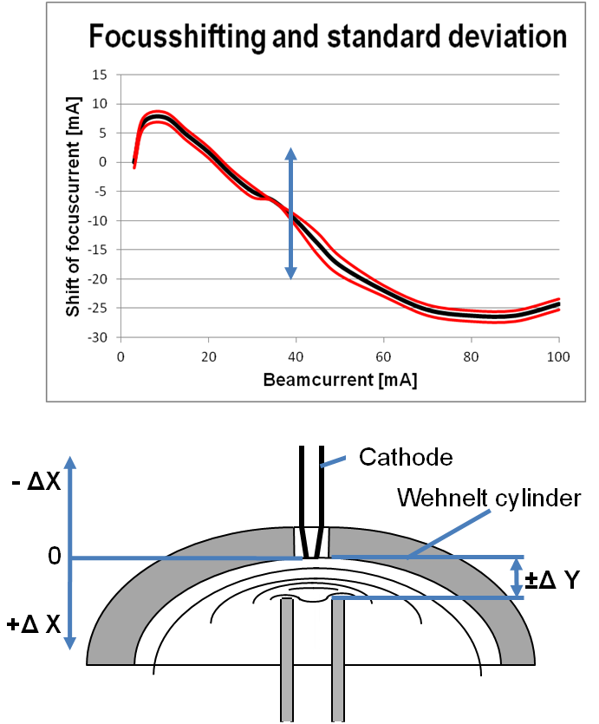
Figure 1: Correlation between change of focus shift with the geometrical conditions in the triode

Options of beam measurement

Measuring beam quality can be conducted by three different basic approaches. The most simple method is the Arata Beam Test, where the penetration shape at specially geared test sheet is analyzed [ii]. The surveying of the electron beam using photographic / optical methods is only possible for very low beam powers [iii]. Furthermore, it is possible to infer on the beam quality using the backscattering electron image of a defined geometry while the beam is oscillated on a test setup. The measurement structure is composed of metals of different density and has different backscattering characteristics [iv]. Alternatively there is the possibility of measuring the beam power density and its distribution directly. Thereby either a wire or slot sensor is moved relative to the beam or the beam oscillates above a hole or slit diaphragm sensor [v,vi].

Measurable variables and their influence

After the analysis of the primary signal the base measuring value is obtained as power density and its distribution. Proceeding from this value it is possible to calculate the equivalent beam diameter. There are two different types of the diameter to be determined.
On the one hand there is the beam diameter d based on the maximum intensity and on the other hand there is the power density diameter d_{p} (Figure 2). The power density diameter dp is one of the most important values for the quality of a weld [vii].
The offset between the edge beam focus and the inner beam focus is also measurable. This offset is caused by spherical aberration of inhomogeneous fields of the focus lens and results in inadequate reproducibility when an unfavorable working distance is selected. With the measurements of the power density and its distribution possible astigmatism and the alignment condition can be evaluated.
Using repeated measurements in different working distances the beam caustic and the aperture angle can be surveyed (Figure 3).
With this values the emittance can be determined which can be declared as the geometrical beam parameter product [i,viii].

Figure 2: Principle of the equivalent beam diameter

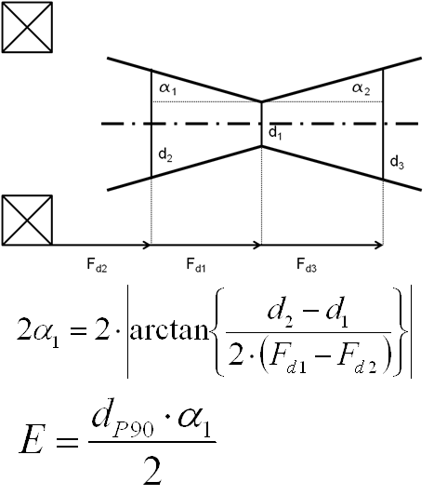
Figure 3: Context of beam caustic, the aperture angle and the Emittance

Diabeam; development of a beam measurement system

During the last 25 years, the ISF has been carrying out research developing manufacturer-independent, uniform standards and measuring methods which permit the objective characterisation of the beam quality and allow also the comparison between different beam generators. Within the scope of this research work, beam sensors as laboratory models which are suitable to correctly measure an electron beam in the plane have been developed. The developed measurement setup consists in a combined slit and hole aperture sensor. The beam oscillates above the sensor while the measurement. Between the single measurements the beam is deflected on a parking area. Using this laboratory system it is possible to carry out stable and reproducible measurements up to a beam power of 15 kW [vii,ix]. Although the system has proven itself for years in the laboratory operation, nevertheless it reveals some disadvantages. Extensive setup operations for calibration and adjustment were needed before any measurement. Because of the outdated controlling and measuring hardware there is a slow data processing.

Diabeam II; Capabilities and Features

Based on these findings, a market-driven product is currently being developed in cooperation with the company aixACCT as a world leading developer of highly-accurate measuring devices.
To this end, the laboratory-tested aperture slit diaphragm sensor system has been further advanced.
The combined slit and hole aperture sensor is maintained but the two linear slits were replaced by a circular. The small construction enables even to measure in small chambers and with low deflection angles (Figure 4).

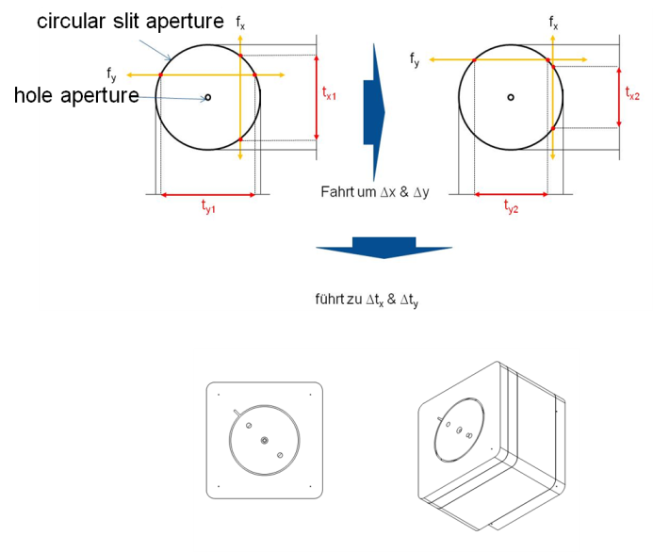
Figure 4: Measurement principle
Due to the robust measuring device and the separation of signal recording, transmission, amplification, etc. beam measurements at high beam powers up to 30 kW are feasible. Between the single measurements the beam is deflected on the parking area. Measurements at high beam currents can be done by various strategies. At older beam generators without fast beam deflection the single line scan can be used (approx. 2-5 s per measurement). At new generation of beam generators with fast beam deflection the deflection field measurement can be used (approx. 0,08-0,3 s per measurement).

The system can be temporarily installed into existing electron beam welding machines. Also a permanent implementation via interface with the equipment control is possible. Thus, automated beam control in regular intervals is possible.
The user-friendly operating software permits simple and clear assembly and also intuitive handling.
Different user-levels are created to use the system
both as a decision assistance in industrial use as well as a scientific instrument with the necessary adjustment possibilities.
The circular slit aperture enables an easy determination of the calibration values and an automatic adjustment by measurement of the signal shift without extensive setup operations by the user (Figure 6). Movement in the Z direction allows the detection of a possible angular deviation of the beam from the central axis.

Figure 5: Automatic calibration and adjustment
By online illustration of the beam diameter d (based on the maximum intensity) and power density diameter d_{p}, the display and measurement of astigmatism is feasible.

Figure 6: Three-dimensional view of the power density distribution

The Z-axis drive unit enables the measurement of the beam caustic in definable steps.
Beam caustic measurements allow the easy determination of the focus shift with increasing beam current and the determination of the real focus point at any beam current (Figure 8).
With these values the identification of the offset between the edge beam focus and the inner beam focus and the calculation of the aperture angle
are possible.

Figure 8: Surveying the beam caustic

The development of the sensors is addressed for different-use facilities.

Industrial use:
Decision support in an industrial operation, whether the tool “beam” meets the required demands.

Scientific use:
More profound knowledge of the welding tool “beam”.

The option of the implementation of additional functions, especially based on demands of the product user, is one aspect of the system architecture respectively the functional structure.
Further suggestions regarding desirable features of the measurement system for use in industrial EB welding machines are welcome.

Acknowledgements
The Welding and Joining Institute RWTH Aachen University, would like to thank the participating partners from the industry for their support. This research project of the ERP Innovation Programme Central Innovation Programme for SMEs (ZIM) was carried out under the auspices of AiF and financed within the budget of the Federal Ministry of Economics and Technology (BMWi) through the program to promote joint industrial research and development.

Bibliography

[i] Ahmadian, M.-A.: Konzeption und Realisierung eines wissensbasierten Maschinendiagnosesystems beim Elektronenstrahlschweißen; Dissertation, RWTH Aachen, 1992
[ii] Arata, Y.: Evaluation of beam characteristics by the AB test method, IIW-Doc.IV-340-83 1983
[iii] Kanaya, K.: Measure of focus properties of an electron probe by means of a shadow image; Bulletin of the electrotechnical laboratory 31 (1967), Nr.2
[iv] Löwer, T.: Verfahren zum Vermessen des Intensitätsprofils eines Elektronenstrahls, insbesondere eines Strahls eines Elektronenstrahlbearbeitungsgeräts, und/oder zum Vermessen einer Optik für einen Elektronenstrahl und/oder zum Justieren einer Optik für einen Elektronenstrahl, Meßstruktur für ein solches Verfahren und Elektronenstrahlbearbeitungsgerät, Deutsches Patentamt, Patentschrift, Aktenzeichen: DE000010232230A1, Inhaber: pro-beam AG & Co. KGaA., 05.02.2004
[v] B. Spies: Beitrag zur Vermessung und Beeinflussung des Elektronenstrahls für eine gezielte Verbesserung der Technologie des Elektronenstrahlschweißens, Dissertation, RWTH Aachen, 1980
[vi] M. Panten: Beitrag zur Realisierung eines Maschinendiagnosesystems und eines adaptiven Fugennachführsystems für das Elektronenstrahlschweißen, Dissertation, RWTH Aachen, 1988
[vii] Weiser, J.: Untersuchungen zu Strahlcharakteristika und deren Auswirkungen auf die Schweißergebnisse beim Elektronenstrahlschweißen, Dissertation, RWTH Aachen, Shaker Verlag, 1994, ISBN: 3-8265-0420-8
[viii] C.G., Menhard; T. Löwer: Die Elektronenstrahlgeometrie – Definition, Vermessung und Bedeutung für den Schweißprozess; Mitteilung aus der pro-beam AG, Planegg, Schweißen und Schneiden 61, (2009), Heft 2
[ix] Dilthey, U.; Goumeniouk, A; Böhm, S.; Welters, T.: Electron beam diagnostics: a new release of the diabeam system, Vacuum, Volume. 62, No. 790, 77-85, 2000

