Economical joining of tubular steel towers for wind turbines employing non-vacuum electron beam welding for high-strength steels

T. Hassel ª, R. Konya ª, M. Collmann ^{b}, P. Schaumann ^{b}, S. Priebe ^{c}, T.A. Deißer ^{d}, A. Beniyash ª, N. Murray ª, Fr.-W. Bach ª
ª Institute of Materials Science, Leibniz University Hanover / Germany
^{b} Institute for Steel Construction, Leibniz University Hanover / Germany
^{c} Siag Tube & Tower GmbH, Leipzig / Germany
^{d} Kjellberg Finsterwalde Schweißtechnik und Verschleißschutzsysteme GmbH, Witten / Germany

Owing to restricted energy resources and the worldwide ambitions to reduce CO2-emissions, renewable energy sources are gaining economical interest and investment. Wind energy is a major technology to increase renewable energy production and still promises great growth potential in terms of market share.
This is closely connected with the increase of plant unit sizes. The wall thickness of the tower construction is rising accordingly and leads to increasing costs for the joining technology. The rising number of weld passes for submerged arc welding (SAW) leads to rising process times as well as a greater heat input.
The employment of Non-vacuum electron beam welding (NVEBW) can significantly reduce the number of passes and the heat input as will be shown in this contribution. A substantial aspect of the control of the welding process is the formation of solidification cracks. Formation mechanisms and solutions will be presented and experimentally backed up.
An additional aim of current research is the overall reduction of the wall thickness of wind turbine towers applying high strength steels. Here it is of chief concern to preserve the advantages of the novel material especially in dynamic stress scenarios. Strategies and their mechanisms are presented and experimentally supported.

1 Introduction

High performance processes have become accepted in the production of towers for wind energy plants which possess conventional seam lengths and forms for submerged arc welding. However, with increasing plate thicknesses of the individual tower segments, the weld seams' working processes and quality assurance are significantly more time consuming. The seam prepartion becomes more intricate, the seam's volume considerably larger and the implementation of the required tolerances and quality also become more time-consuming. The construction‘s throughput times increase drastically.
For this reason, a key objective is to reduce the number of weld passes and thereby the production time. Along with this, the heat input and the consumption of filling material is also reduced. Fig. 1 depicts the considerable reduction in the joint preparation and the number of weld passes for a plate thickness of 30 mm. Here, an attempt is made to increase the seam's web width of the double Y butt weld from the current 5 mm to 18 - 20 mm.
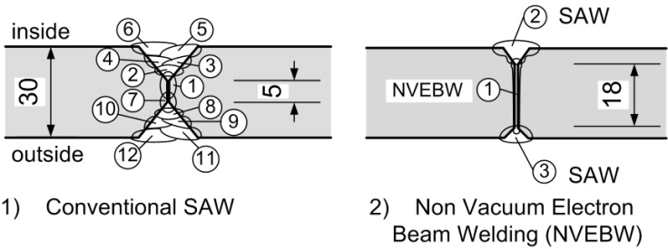
Fig.1 Comparison of the joint preparation, weld passes and welding sequence

In order to be able to implement the objective of increasing the web width, it is necessary to employ new joining technologies. Tremedous potential is offered by non-vacuum electron beam processes (NVEBW) in the field of high performance welding techniques. The technical equipment for this is already available at the Institute of Materials Science in Hanover and provides the possibility of investigating the NVEBW process with regard to its application for welding thick plate [1, 2].

Another approach is to reduce the plate thickness by means of employing high strength, thermomechanically rolled or water quenched fine grained structural steels. With their very good welding properties and elevated strengths, these steels provide the possibility of reducing cross-sectional dimensions and thereby lowering the plate thickness. In order not to impair the positive material properties by means of high energy inputs, the requirements of the heat control significantly increases during the welding. For this reason, high performance joining processes, such as NVEBW, also provide a targeted and decidedly reduced heat input in contrast to SAW.

2 SAW of tubular steel towers of wind energy converters

As an electric arc welding process, submerged arc welding belongs to the high performance processes which have a long tradition and a wealth of experience in being employed for joining bulky components possessing large cross-sectional joints. For this reason, the welding of long, straight and circumferential seams belong to the main field of application of this process. In particular, this process is employed in the steel construction, bridge and ship building, pressure vessel and pipe manufacturing industries as well as in mechanical and automotive engineering and in the offshore industries. High performance processes have also become accepted in the production of towers for wind energy plants which possess conventional seam lengths and forms for submerged arc welding.
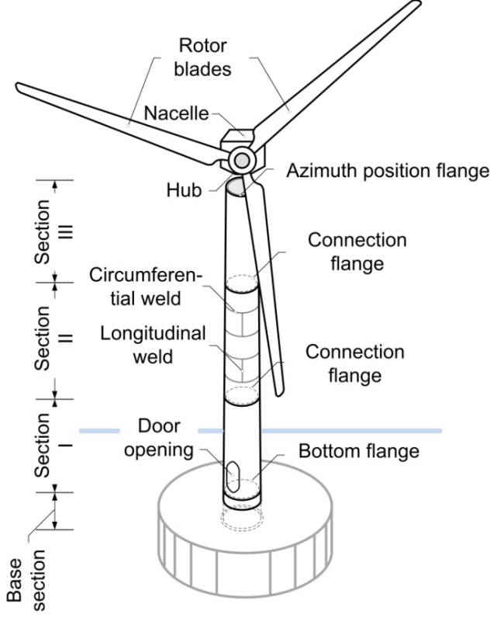
Fig. 2 Tubular steel tower with nomenclature

Self-supporting, solid-walled, tubular steel towers, such as that depicted in Fig. 2 are the currently preferred construction for wind energy plants. The advantages of this type of construction lie in the consistently high factory manufactured quality and the rapid on-site assembly.
SAW belongs to those welding processes in which the welding zone and the solidifying seam are protected beneath of a layer of mineral fusible powder. By means of the protecting powder, or molten slag which is thereby formed, a closed welding chamber is created and it is therefore possible to produce a stable welding process which is protected from the atmosphere. In this way, the welding current strength, voltage and velocity can be widely varied. The diverse applications can be further enhanced by process options using multi-wire combinations.
The current strength for 3 to 5 mm diameter conventional wire electrodes depend on the chosen process option and lie between about 300 and 1,200 A for welding voltages between 25 and 40 V. Using these parameters, deposition rates of up to about 15 kg/h and welding velocities from 30 to 120 cm/min can be obtained for multi wire applications. For example, 20 mm thick plates with a V butt weld can be joined in 8 passes using an average welding velocity of 0.6 m/s, a current strength of 450 to 600 A and a voltage of 27--32 V.
To summarise, the following basic requirements can be derived for the NVEBW:
- lower number of passes and thereby an increase in the throughput time and reduction of the seam volume
- good mechanical properties (hardness, toughness, fatigue strength) for high dynamic load carrying ability
- lower heat input to lower the weld distortions
- good gap-bridging ability owing to the achievable tolerances of the cutting processes
- simple to integrate into the production of large components

In order to establish a comparative basis for further investigations, comprehensive welding tests were carried out by the tower manufacturer SIAG Tube & Tower GmbH. Three 500 x 700 mm weld-specimen plates of the steel grade S355 J2+N each having thicknesses of t = 20 mm, 30 mm and 40 mm were welded as double Y butt joints using the available multi-wire submerged arc welding technology. In order to weld each of the three specimens as reproducible as possible, welding instructions were issued by the tower manufacturer SIAG. The tests were performed during manufacturing operations on SAW-equipment used for welding long seams.
The joint preparation was produced by means of flame cutting and subsequently smooth grinding. The root bead was, as a rule, welded using the single-wire process. The tandem process was, as far as possible, employed for the filler and covering beads. The specimens were initially measured in order to determine typical manufacturing tolerances.
During the welding, the welding parameters; voltage and current strength as well as the welding velocity and time, were measured and documented. To record the temperature cycle times during the welding, thermocouples of type K, I with d= 0.5 mm are located at various intervals from the seam's chamfer, starting with a distance of 15 mm. The specimens having t = 20 mm were also furnished with strain gauges; 0°/90° T-rosettes, for measuring the strain components in the x and y directions.
As an example, the measured data from the specimens having 20 and 30 mm plate thicknesses, are respectively shown in Tab. 1 and Tab. 2. Polished sections of specimens 20.2 and 30.1 are depicted in Fig. 3.
Generally, it should be noted that it is difficult to reproduce the welding tests, even for plates having the same thickness. The specimens widely differ with respect to their geometric boundary conditions; gap dimension, off-set and opening angle, such that they have to react differently to the given situation during welding. In Tab. 2, this is demonstrated for each internal and external pass, particularly regarding the number of passes and the maximum temperatures at the 15 mm distance to the seam's chamfer.
Tab. 1 Summary of the test data for the 20 mm thick plate specimens of material S355 J2+N
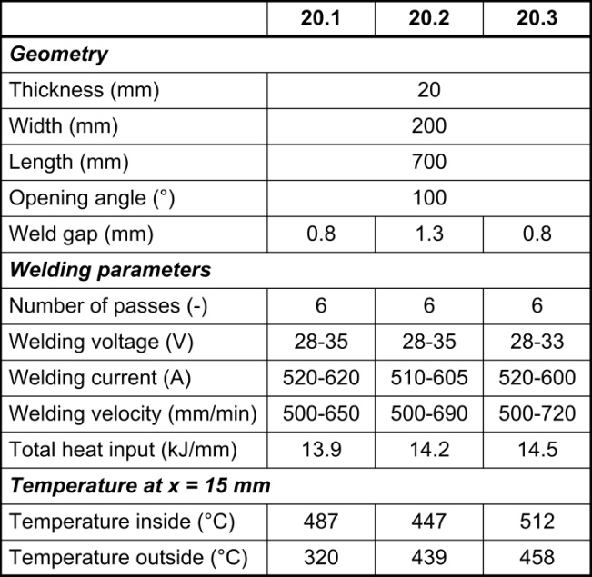

Tab. 2 Summary of the test data for the 30 mm thick plate specimens of material S355 J2+N
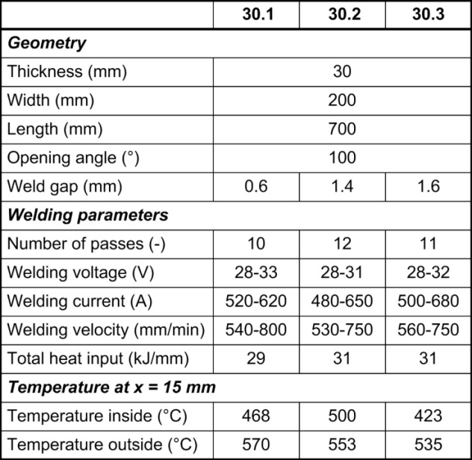

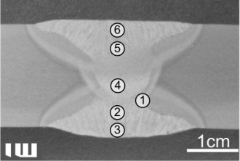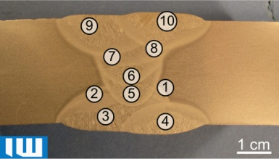
Fig. 3 Macrosections of specimens 20.2, top and 30.1, bottom

3 State of the art of NVEBW

NVEBW is a type of electron beam welding process in which the beam is also produced in a high vacuum but the welding is performed in air. The electron beam is transferred from the vacuum in the beam generating chamber to the atmosphere via a pressure stage system through several pressure stages. Thus, the need to transfer the component to a vacuum chamber is eliminated for NVEBW. Owing to this, the process can be easily integrated into the production of large components.
The atmospheric conditions influence the electron beam during welding. The major influence is the electron beam's scattering due to the elastic impact with atmosphere's atoms and molecules. This results in two important properties for NVEBW. Owing to the electron beam's broadening, the energy density in the beam sinks by which the achievable welding depth is reduced in comparison to electron beam welding in a vacuum.
By means of using the welding depth effect and depending on the power and working distance, 30 mm penetration depths can be obtained. A further effect of the electron beam's broadening is that large process tolerances can be generally accepted for beam welding processes; for example, for gaps in butt joints or edge off-sets [6, 7].
The application of NVEBW for joining high strength steels (S960QL, S1100QL, S1300QL) has been investigated for plate thicknesses from 6 mm to 11 mm [8, 9]. Laser-cut edges were employed for the joint preparation. For all the tests, the welding velocity was 2.5 - 3 m/min and the beam current lay in the range 100 - 130 mA (17.5 - 22.75 kW). A 1.2 mm cold wire (X90 / GMn4Ni2CrMo) was employed as the filler material with which it was possible to weld 2 mm gap widths using a single pass.
Tab. 3 Mechanical tensile tests 6 mm welded joints (filler wire X90 / S960QL and without filler wire) [9]
Material | Vs [m/min] | σ_{t}  [MPa] | σ_{0.2}  [MPa] | Character of fracture
Parent material
S960QL | - | 980-1150 | 960 | -
S1100QL | - | 1200-1500 | 1100 | -
S1300QL | - | 1400-1700 | 1300 | -
Welded joints
S960QL | 3.0 | 1190 | 1037 | Parent metal
S1100QL | 2.5 | 1485 | 1420 | HAZ
S1300QL | 2.5 | 1440 | 1385 | HAZ
Results for the 6 mm plates are listed in Tab. 2. The fracture location in the heat affected zone (HAZ) for S1100QL and S1300QL was attributed to a drop in hardness value in the HAZ, in which the strength of the parent material was obtained. Summarising; it was possible to produce high quality weld seams in 11 mm thick high strength steel plates using the NVEBW process.
In addition to this, up to 20 mm thick plates of the ship construction steel D36 were investigated in [9]. Here, droplet formation occurs at the weld seam's root without supporting the weld pool for plate thicknesses above 10 mm. To avoid defects in full penetration welds, weld pool support is recommended for large plate thicknesses.

4 NVEBW of tubular steel towers of wind energy converters

The primary objective in applying NVEBW is to reduce the required number of welding passes by means of raising the web widths from 5 mm to 18 - 20 mm for 30 mm thick plates.
Plates (t = 20 mm) having 14 mm web widths were joined. The results and welding data without heat treating and without using filler material are presented in Tab. 3 and Fig. 4. Current work concerns plate thicknesses of 30 mm.
The welding sequence is specified as follows: Firstly, the SAW root bead is welded. The web was then subsequently welded using NVEBW such that SAW root bead is welded in. Finally, another SAW pass follows as a covering bead. Here, the initial SAW root bead acts as a weld pool support for the NVEBW seam thus preventing the melt flowing out during the web's joining process for widths above 10 mm. If large or varying gap dimensions exist, then the final SAW covering bead can be used to completely fill the lacking seam volume and to avoid seam sinkage. This is necessary if the NVEBW seam is to be joined without filler material.
Tab. 4 Summary of the test data for a NVEBW seam with SAW root and coving beads for 20 mm thick plate specimens of S355 J2+N material
SAW
Number of passes (-) |  |  | 2
Welding velocity (mm/min) |  |  | 350
Welding voltage (V) | 28,5 | Welding current (A) |  | 330
Total heat input (kJ/mm) |  |  | 3,2
NVEBW
Number of passes (-) |  |  | 1
Welding velocity (mm/min) |  |  | 1000
Acceleration voltage (kV) | 175 | Beam current (mA) |  | 100
Total heat input (kJ/mm) |  |  | 1,1
SAW+NVEBW
Total heat input (kJ/mm) |  |  | 4,3
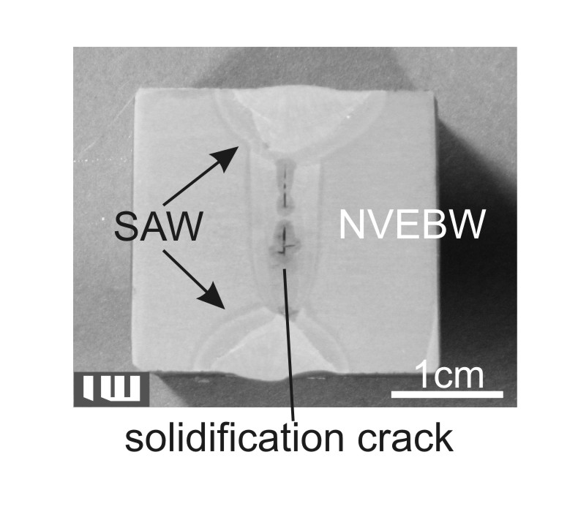
Fig. 4. Macrosection for the parameters listed in Tab. 3, with 14 mm web widths and solidification crack in the region of the NVEBW seam

If one compares the total energy input between SAW (Tab. 1) and SAW+NVEBW (Tab. 4), then one clearly discerns the lower heat input for the SAW+NVEBW combination as 4.3 kJ/mm and approx. 14 kJ/mm for just SAW. This is accompanied by a significantly lower seam volume and therefore consumption of filler material. In addition to this, the number of passes can be reduced from 6 to 3 beads for the 20 mm thick plate. This gain in advantage is increased still further for 30 mm plate thicknesses since here the number of passes remains at 3 whilst those for SAW increase to 10 - 12.
Welding of thick plates made of fine-grained steels and high strength steels with the non-vacuum electron beam needs to respond to the following challenges:
- solidification cracking
- pore formation
- fluctuation of welding depth
- influence of seam gap
- root formation
- fatigue restistance
Fatigue resistance is a particular difficulty for high strengtg steel and will be addressed separately in chapter 6. Chapter 5 will deal with solidification cracking.
Pore formation can be present in the lower section of NVEB-weld seams. Preheating to improve the degassing of the weld pool as well as providing a clean and dry welding atmosphere are both suitable to significantly reduce pore formation. This could be comprehensively shown for a preheating temperature of 200°C and subsequent NVEB-welding.
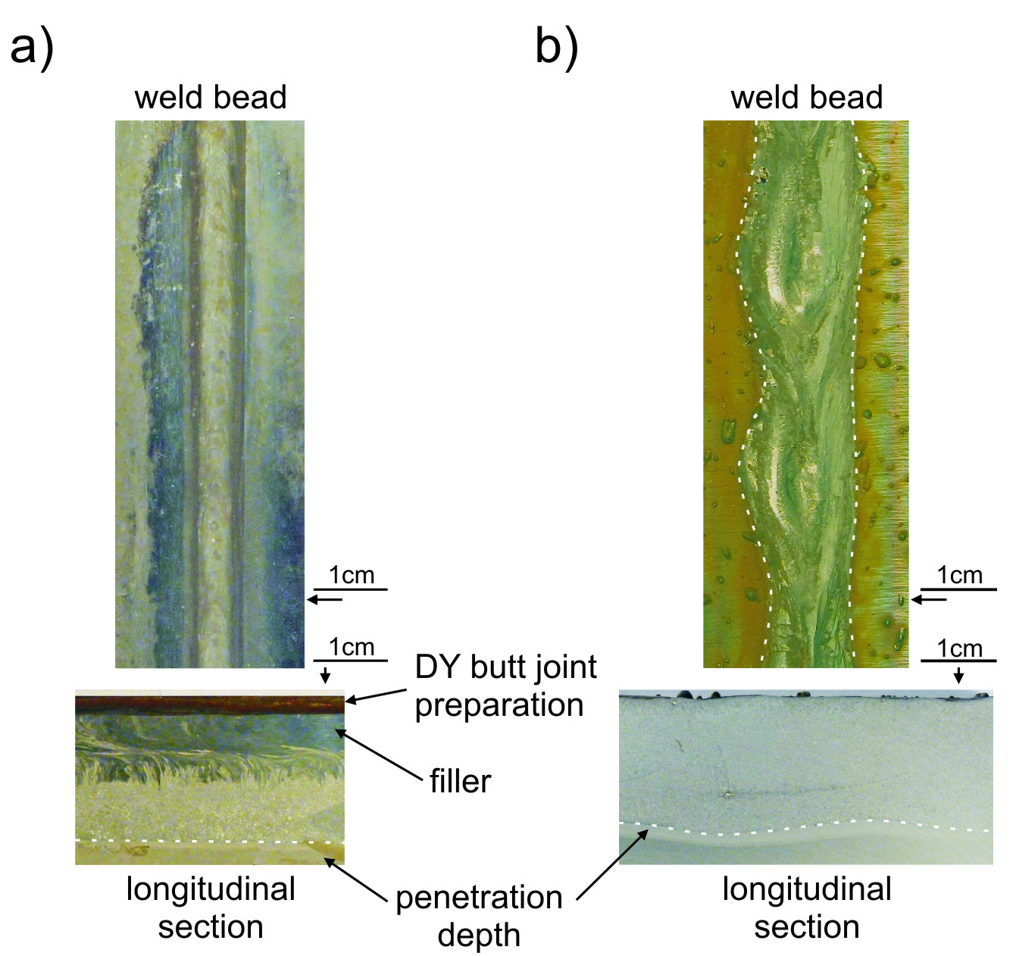
Fig. 5. a) regular and steady penetration depth and weld seam formation, material: S690, DY butt joint with filler, gap width 0.7 mm. b) fluctuating penetration depth and weld seam, material: S460, bead on plate weld.

A fluctuation of penetration depth with an amplitude of 1.5 to 2.5 mm can occur. This effect is accompanied by a periodic fluctuation of weld seam width, see Fig. 5 b). In Fig. 5 a) a weld seam without these imperfections is shown. The welding was done as a DY butt joint with a 0.7 mm gap using filler material. No fluctuation of penetration depth or weld seam width is present. It can be suspected that the main influence is due to the presence of the weld gap. Welding of towers for wind turbines is an application with highly varying weld gap widths, see tables 1 and 2. This can critically influence penetration depth. To allow for a stable seam formation some measures have to be met. A web width of more than 10 mm can lead to an outflow of molten material. To address this it is favourable to leave a few millimetres of extra web width to act as backing for the melt pool. Alternativly it is possible to provide a SAW root layer first and use NVEBW as a second step.

5 Solidification cracking during NVEBW

A typical defect formed during the welding of larger plate thicknesses can be seen in Fig. 4. In order to establish the type of defect, such as a hot crack, cold crack or pores, scanning electron microscope images were taken of the crack’s surface. For this purpose, a sample containing the defect was cut from the defect's region and was fractured by bending so that one can directly observe the defect's surface using the scanning electron microscope (Fig. 6).
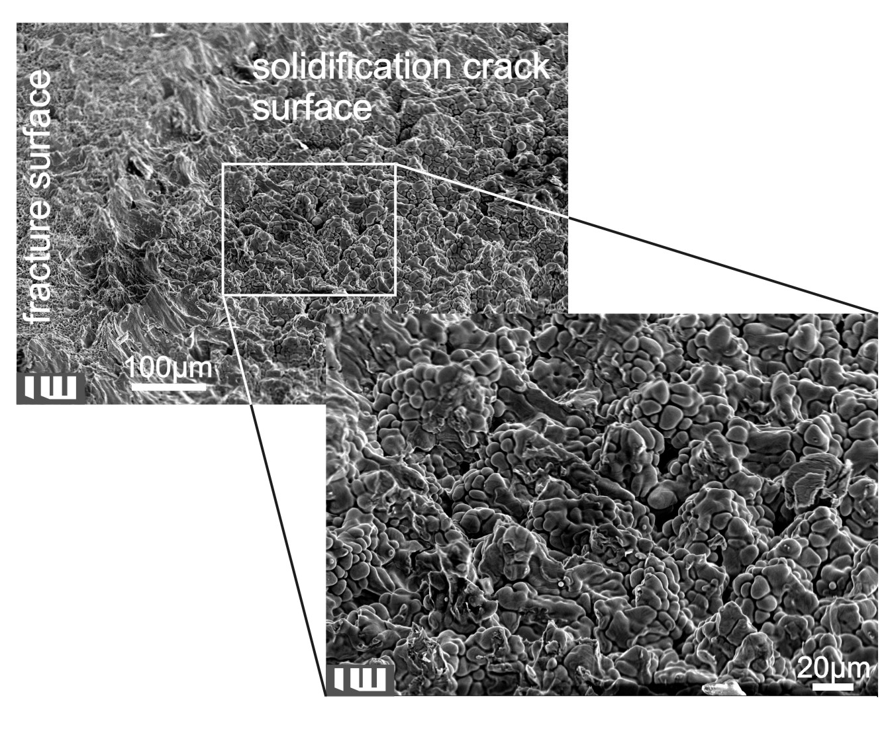Fig. 6. SEM image of the defect's surface

Here, the crack’s surface shows the formation of dendrites without any discernible deformation.
This indicates that no contact with the opposite dendrites occurred during the solidification process. It follows from this that the crack arose during solidification [12].
After determining the type of defect, suitable measures must be implemented for its avoidance.
Basically, these preventive measures against solidification cracking can be divided into three groups. This includes lowering the loading on the weld seam during cooling by means of reducing the welding stresses; for example, by controlling the temperature profile via pre- or post heating. Another possibility lies in influencing the melts solidification in order to avoid the unfavourable, crack forming growth of dendrites. This can, for instance, be acheived by producing a fine grained microstructure. A fine grained structure is promoted by means of introducing suitable alloying elements or nucleating agents. This leads to the third possibility of either alloying via the filler material in order to avoid low melting point eutectics or influencing the grain boundary wetting (dihedral angle) in order to avoid the formation of solidification cracks.
In order to avoid the formation of solidification cracking during the welding of S355 by means of preheating, our investigations demonstrate a marked effect. Both weld beads on plates as well as butt welds have been investigated for the same parameters with and without preheating to 200 °C. Longitudinal, polished samples were used in order to be able to evaluate the formation of cracks along the length of the weld seam. The results are depicted in Fig. 7.
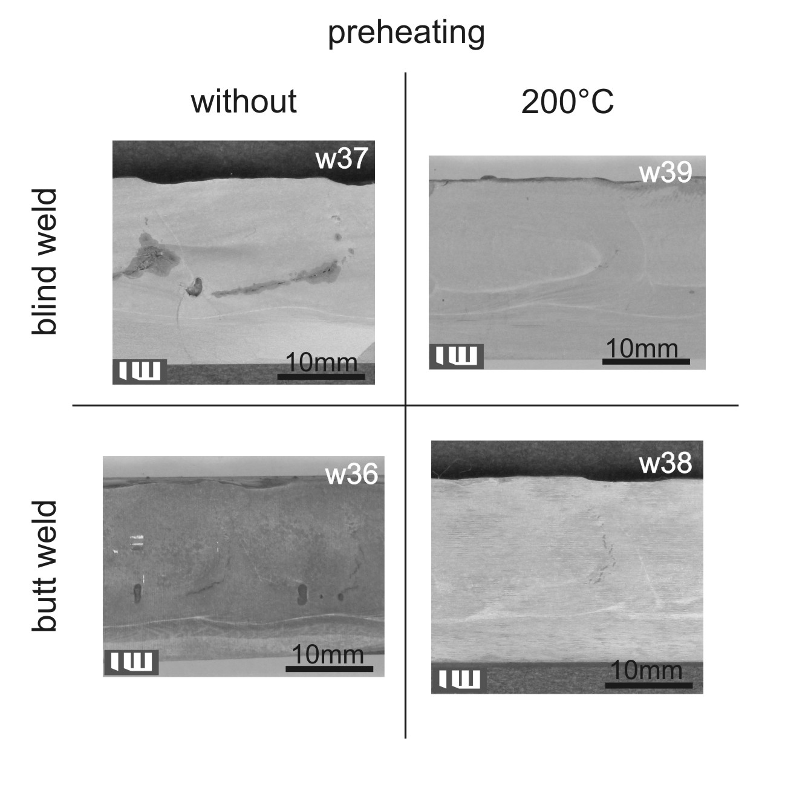Fig. 7. Longitudinal, polished samples for solidification cracking with and without preheating

The test showed that the tendency to form solidification cracks can be significantly reduced or totally eliminated by means of preheating to 200 °C. Using the example in Fig. 7, it was possible to observe isolated solidification cracks in specimen w38 but no cracks could be established in specimen w39.

In other investigations, filler materials were investigated for eliminating the formation of solidification cracks. One important aspect is the assessment of the blending of bulk material and filler. Weldments using solid wire G 18 8 Mn as filler material were produced and then analysed by EDX and macrograph. Comparing the concentration of specific alloy materials from the filler wire, chromium, nickel and manganese show a clear drop of concentration from top of the weld to bottom, see Tab. 5.

Tab. 5: Concentration of specific alloy metals from the filler material
Position | Concentration [w%]
 | Cr | Ni | Mn
Bulk material | 0.33 | 0.04 | 1.53
Top weld | 3.9 | 1.6 | 2.3
Centre weld | 4.6 | 2.0 | 2.5
Weld root | 2.5 | 1.0 | 1.8

Further investigations will look further into the distribution of S, P and O₂, which aggravate solidification cracking, as well as Mn, which counteracts crack formation [12].

6 High strength steels

On employing high strength steels in dynamically loaded structures, a problem arises in that the elevated strength is not synonymous with an increased fatigue strength. If it is established that fatigue is decisive for dimensioning, then the advantage of higher strength can not be gained owing to the elevated notch sensitivity (Fig. 8). Here, welded joints are regions of central importance. The weld's transition region represent a geometrical notch at which additional crack promoting tensile residual stresses exist due to the welding process.
Suitable methods are resorted to for post-working weld seams, such as the hammering processes PIT or UIT. On the one hand, these procedures induce compressive residual stresses and, on the other, form the seam's transition region in order to markedly delay fatigue crack initiation in these critical regions of a weld seam [13, 14].
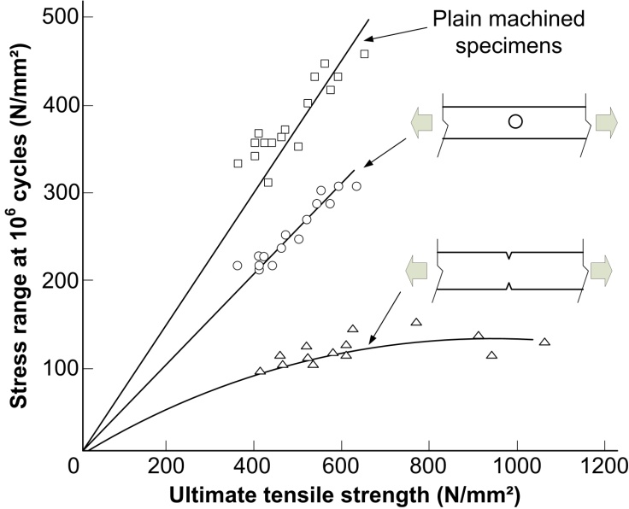
Fig. 8. Fatigue strength of steels possessing high strength and differently notched specimens [15]

Steel tube towers of wind energy plants are also severely fatigue loaded structures with high numbers of loading cycles. Based on this necessity and in order to be able to exploit the advantages of high strength steels, the PIT procedure; a high frequency hammering process, is employed in order to treat the manufactured joint connections. The joint connections involved here are the NVEBW seams with SAW covering and root beads. Owing to the favourable seam transition regions for SAW, these also have an alleviating effect on the notch sharpness.
Cyclic loading fatigue tests will be subsequently carried out on these connections in order to evaluate their suitability. In addition to this, toughness proof testing will be performed using Charpy V-notch impact tests.

7 Conclusions

Increasing sizes of wind energy plants also lead to higher supporting structures. This is also accompanied by increasing wall thicknesses and rising demands on the joining technology, these factors are associated with growing costs.
To counter this, two possibilities have been presented. On the one hand, employing a high performance joining process (NVEBW) which can be used to significantly reduce the necessary number of weld passes, the weld seam's volume and the heat input. One challenge of employing the NVEBW, as well as other beam welding processes, is the formation of solidification cracks in the middle of the seam. It has been shown that it is possible to significantly reduce or completely eliminate these under the given boundary conditions by means of a suitable preheating. Further investigations will be performed on using filler material in order to avoid, for example, low melting point eutectics.
Another possibility is to employ high strength steels which provide the potential for reducing the wall thicknesses. In doing this, it should be taken into account that the advantages of high strength steels are not automatically gained for dynamically loaded structures. Notch effects and tensile residual stresses in the seam's region have unfavourable effects on the fatigue life or the attainable number of load reversals.
For this reason, a method for post-treating weld seams (PIT) will be employed in order to smooth out the seam’s transition regions as well as to introduce compressive residual stresses at these regions which are critical to cracking.
A combination of high strength steels and NVEBW with SAW root and covering beads will be subsequently evaluated in cyclic loading fatigue tests and Charpy V-notch impact tests.

8 Acknowledgements

The authors would finally like to thank the German Ministry for Environment, Nature Conservation and Reactor Safety for their financial support for executing the project „OPTIWELD - Ökologische und ökonomische Hochleistungsfügetechniken für Stahlrohrtürme von Windenergieanlagen“ and the German Ministry for Economy and Technology for their financial support for executing the project "Nutzung des Leichtbaupotentials von hochfesten Stahlwerkstoffen für Stahlrohrtürme von Windenergieanlagen durch den Einsatz von Hochleistungsfügetechnik".

9 Literature

[1] Schaumann, P., Mickley, M., Hassel, T., Deißer, T.A., Priebe, S., Konya, R., Bach, F.-W.: Challenges in Joining Thick Metal Sheets for tubular steel towers of wind energy converters. Proceedings EUROSTEEL 2011
[2] Deißer, T.A., Priebe, S., Schaumann, P., Mickley, M., Hassel, T., Konya, R., Bach, F.-W.: Verfahrenstechnische Herausforderungen beim Fügen dicker Bleche mit dem Elektronenstrahl an Atmosphäre und einem Plasma-UP-Hybridverfahren, Schweißen im Schiff- und Ingenieurbau, 2011
[3] Dilthey, U.: Schweißtechnische Fertigungsverfahren 1 – Schweiß- und Schneidtechnologien. 3. Auflage, Springer-Verlag Berlin Heidelberg, 2006
[4] DVS Merkblatt 0915: Unterpulver-Mehrdraht-schweißen. 2000
[5] Hochreiter, G.: Unterpulverschweißen in der Praxis. expert-Verlag, Renningen-Mahlsheim, 1995
[6] Schulze, K.-R.: Ja wieso denn Elektronenstrahlschweißen? – Teil 6: Komm raus, Strahl! Nonvac-EBW: Elektronenstrahlschweißen an freier Atmosphäre. Schweißen und Schneiden 63 (2011), Issue 9, pp. 536-542, 2011
[7] Szelagowski, A.: Beitrag zur Nonvakuum-Elektronenstrahlschweißtechnik. Dissertation, Fortschritt-Berichte VDI, Reihe 2 Fertigungstechnik, Nr. 627, VDI Verlag GmbH Düsseldorf, 2003.
[8] Schwantes, S., Gerster, P., Schulze, K.-R.: Schweißen der höchstfester Feinkornbaustählre S1100QL und S1300QL – Ein Vergleich des Elektronenstrahlschweißen an Atmosphäre mit einem Plasma-MSG-Hybridverfahren. Aachener Berichte Fügetechnik, pp. 543-557, 2007
[9] Bach, Fr.-W., Beniyash, A., Lau, K., Konya, R.: Nonvacuum electron beam welding of structural steels. The paton welding journal, Issue 5, pp. 22-26, 2009
[10] Dilthey, U., Olschok, S.: Untersuchungen zur Nutzung der Synergieeffekte beim Hochleistungs-Laser-Hybridschweißen von dickwandigen Rohrkörpern aus C-Mn-Stählen. AiF 13.407 N, 2005
[11] Dilthey, U., Woeste, K.: Elektronenstrahlschweißen bei der Fertigung von dickwandigen Großrohren aus C-Mn-Stählen. AiF 12.187 N, 2001
[12] Schuster, J.: Heißrisse in Schweißverbindungen – Entstehung, Nachweis und Vermeidung. DVS-Berichte, Band 233, ISBN 3 87155 690 4, 2004
[13] Kuhlmann, U., Dürr, A., Bergmann, J., Thumser, R.: Effizienter Stahlbau aus höherfesten Stählen unter Ermüdungsbeanspruchung. research project P 620 Forschungsvereinigung Stahlanwendunge e.V. (FOSTA), Verlag und Vertriebsgesellschaft Düsseldorf mbH, Düsseldorf, 2006
[14] Ummenhofer, T., Weich, I.: REFRESH-Lebensdauerverlängerung bestehender und neuer geschweißter Schweißkonstruktionen. research project P 702 Forschungsvereinigung Stahlanwendunge e.V. (FOSTA), Verlag und Vertriebsgesellschaft Düsseldorf mbH, Düsseldorf, 2011
[15] Gurney, T.R.: Fatigue of welded structures, Cambridge University Press, 2nd edition,1984

